- Introduction
  - What is monte Carlo
  - What is a random walk
  - Where is it used
    - Nuclear reactors
- Theory
  - Monte Carlo integration
  - Inverse CFT method
  - Random number generation
  - Psudo-random number generation
  - Attenuation length in material
    - Definition etc
- Method
  - Material details used – list them
    - Or table
  - Checking random numbers are random
  - Isotropic random walk check
  - Combining the inverse CFT method with the random walk
  - Object oriented approach explained
    - Basic code functionality and what it does
  - Cockwood method
- Results
  - Absorption only spectrum and mean free path
  - For each material calculate macroscopic absorption and scattering cross section through a slab of material
  - Percentages of neutrons transmitted, absorbed, reflected through a 10cm block

- Analysis
  - For 4.c – how does the number of neutrons used varies with error
  - Errors in attenuation length – using the simulation multiple times
  - Woodcock method calculates the fraction of neutrons transmitted through two slabs of different materials in contact with each other. Each of thickness 10cm.
- Conclusion
- References

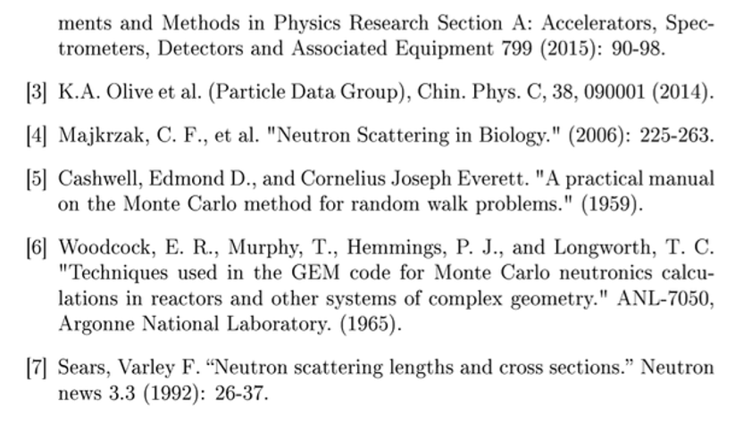
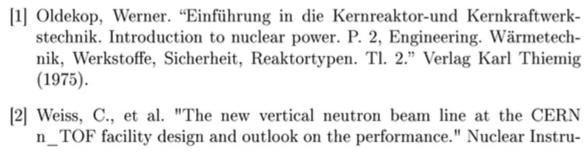
Editting page

